SUBJECT: OBJECT ORIENTED PROGRAMMING

Submitted To: Engr. Asmatullah

Submitted By: Asadullah Samo (21SW036)

Dated: 01-08-2022

Lab: Lab-05 Tasks

**Question 01:**

Create a class having 4 functions, add, sub, mul and div. Each function accepts 2 parameters and returns the sum, difference, multiplication and division of these numbers. Create a main class having main function that uses the above class.

Source Code:

**package** Lab_05_Tasks;

**import** java.util.Scanner;

**class** Maths{

**public** **void** addition(**int** num1, **int** num2){

System.out.println(num1+"+"+num2+"="+(num1+num2));

}

**public** **void** sub(**int** num1, **int** num2){

System.out.println(num1+"-"+num2+"="+(num1-num2));

}

**public** **void** multiply(**int** num1, **int** num2){

System.out.println(num1+"*"+num2+"="+(num1*num2));

}

**public** **void** div(**int** num1, **int** num2){

System.out.println(num1+"/"+num2+"="+(num1/num2));

}

} // end of class Maths

**public** **class** Lab_05_Task_01 {

**public** **static** **void** main(String[] args) {

Scanner sc = **new** Scanner(System.in);

System.out.print("Enter first number: ");

**int** num1 = sc.nextInt();

System.out.print("Enter second number: ");

**int** num2 = sc.nextInt();

Maths m1 = **new** Maths();

m1.addition(num1, num2);

m1.sub(num1, num2);

m1.multiply(num1, num2);

m1.div(num1, num2);

} // end of main() method

} // end of program

OUTPUT:

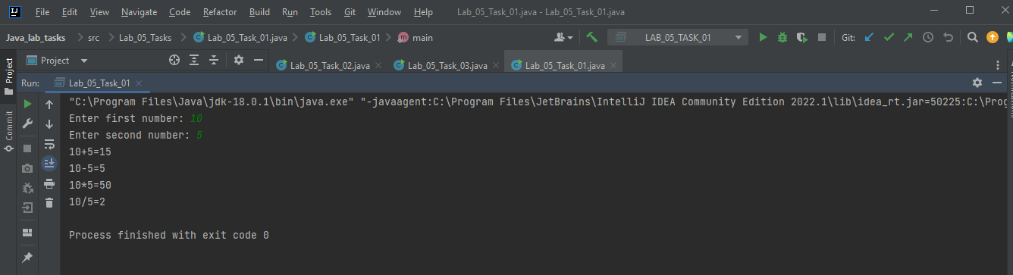

**Question 02:**

Demonstrate the use of the following:

Constructors, Accessors and mutators, static class members.

Source Code:

**package** Lab_05_Tasks;

**class** Employee{

**private** String name;

**private** **int** age;

**static** **float** height = 9.8f;

// Demonstrating Constructors

Employee(){

System.out.println(" Hi, I am constructor. I will be called automatically");

}

// Demonstrating mutators and accessors

**public** **void** setName(String name){

**this**.name = name;

}

**public** **void** setAge(**int** age){

**this**.age = age;

}

**public** String getName(){

**return** name;

}

**public** **int** getAge() {

**return** age;

}

} // end of class Employee

**public** **class** Lab_05_Task_02 {

**public** **static** **void** main(String[] args) {

// Constructors example

Employee e1 = **new** Employee();

// mutators and accessors

e1.setName("Asad");

e1.setAge(17);

System.out.println("Employee name is "+e1.getName());

System.out.println("Employee age is "+e1.getAge());

// Demonstrating static class members

System.out.println("Student height is "+ Employee.height);

} // end of main() method

} // end of program

OUTPUT:

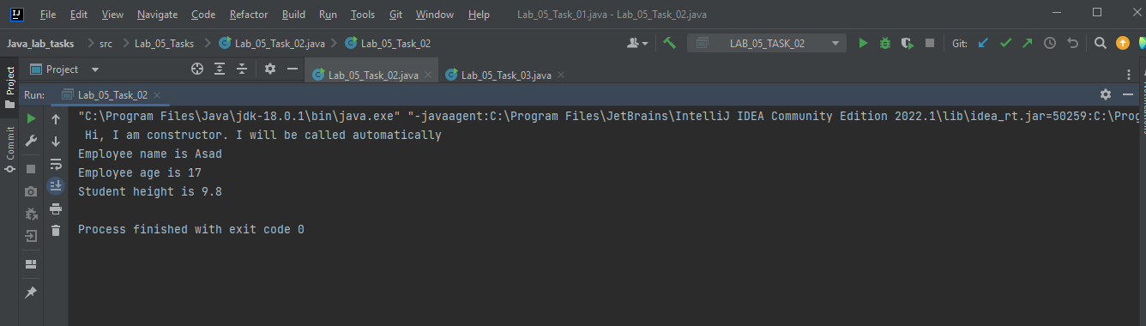

**Question 03:**

Create a Student class that stores student data, provides methods for initializing and displaying student data. Also provide a parameterized constructor for initializing student class data members.

Source Code:

**package** Lab_05_Tasks;

**class** Student{

**public** **int** age;

**public** String name;

**public** **float** height;

Student(**int** age, String name, **float** height){

**this**.age = age;

**this**.name = name;

**this**.height = height;

}

**public** **void** initialize(**int** a, String n, **float** h){

age = a;

name = n;

height = h;

}

**public** **void** display(){

System.out.println("Student name is "+name);

System.out.println("Student age is "+age);

System.out.println("Student height is "+height);

}

} // end of class Student

**public** **class** Lab_05_Task_03 {

**public** **static** **void** main(String[] args) {

Student s1 = **new** Student(18, "Asad", 6);

s1.display();

s1.initialize(27, "Junaid", 6.36f);

s1.display();

} // end of main() method

} // end of program

OUTPUT:

